**4 charged in human trafficking investigation in Va. Beach**

VIRGINIA BEACH, Va. (WAVY) — Four people face charges in connection to a prostitution and human trafficking investigation.

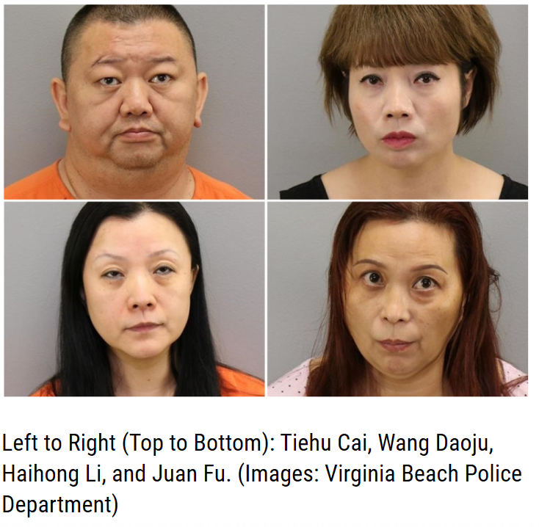

Authorities arrested 45-year-old Tiehu Cai, 43-year-old Wang Daoju, 50-year-old Haihong Li, and 50-year-old Juan Fu

Cai is charged with maintain or frequent a bawdy place, using vehicle to promote prostitution and pander, pimp or receive money from prostitute.

Daoju is charged with solicitation for prostitution and maintain or frequent bawdy place. Li is charged with prostitution, adultery or fornication for money, etc., and maintain or frequent a bawdy place

Fu is charged with maintain or frequent a bawdy place and using vehicle to promote prostitution.

Their charges come after Homeland Security investigators and Virginia Beach police [**raided the three massage parlors**](https://www.wavy.com/news/local-news/virginia-beach/human-trafficking-investigation-in-virginia-beach/) and another business across the city on Thursday, June 13.

The raid included the massage parlor in the Kempsville Plaza. The other businesses were on Princess Anne Road, Independence Boulevard and General Booth Boulevard.